**Task Description**

**AWS Task - 4**

Launch an EC2 instance (Linux and Windows) along with a web server. Then, create an EBS volume of 5 GB, attach it to an EC2 machine (Linux and Windows), and take a snapshot. Finally, create an EBS volume using the taken snapshot.

**Step 1: Launch Two EC2 Instances**

**1.1 Launch Linux Instance**

* Navigate to **EC2** and click on **Launch Instances**.

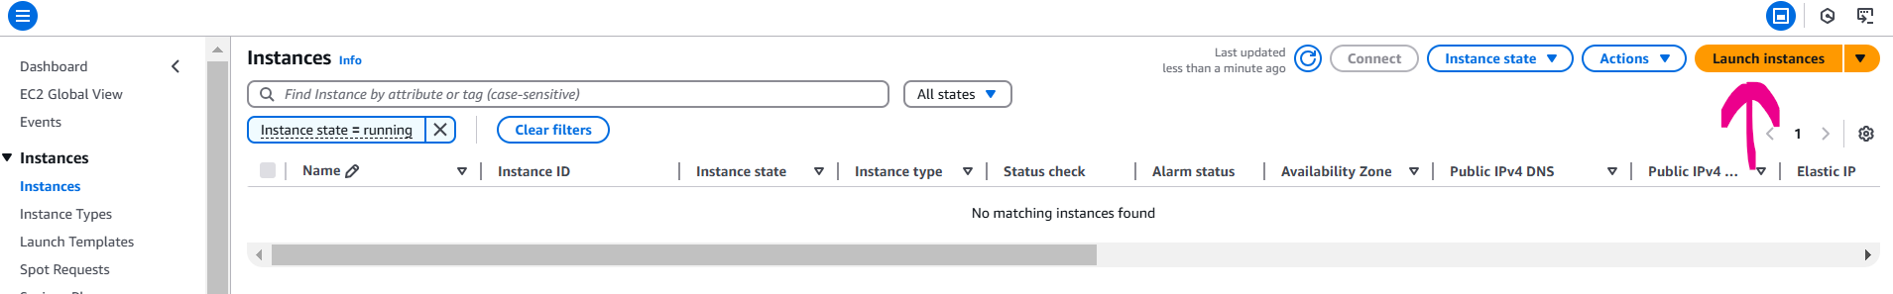

* Name: **my_linux_instance**
* Select an Amazon Machine Image (AMI) (**Amazon Linux 2023 AMI**)

* Choose an instance type **(t2.micro**).

**Configure security group:**

* Add inbound rules to allow HTTP (port 80) and SSH (port 22).
* Key pair: proceed without a key pair
* Launch the instance.

**1.2 Launch Windows Instance**

* Navigate to **EC2** and click on **Launch Instances**.
* Name: **my_windows_instance**
* Select an Amazon Machine Image (AMI) (**Microsoft Windows Server 2022 Base**)

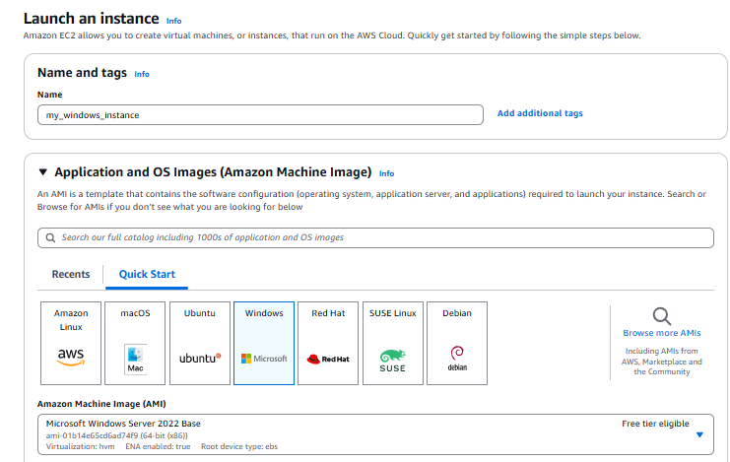

* Choose an instance type **(t2.micro**).

**Configure security group:**

* Add inbound rules to allow RDP (port 3389) and HTTP (port 80).
* Key pair: proceed with **aws_windows_instance** (Which I already created)
* Launch the instance.

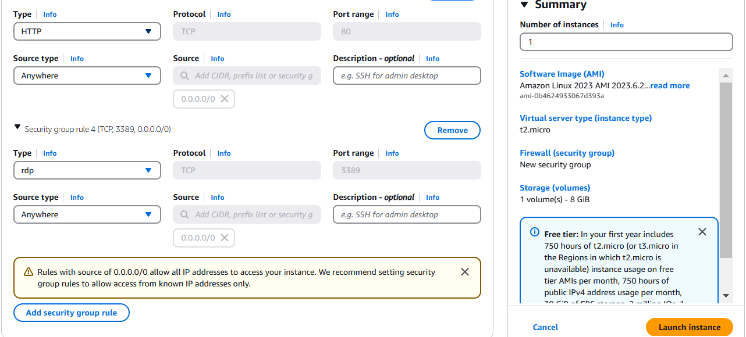

**Step 2: Install Web Servers**

**2.1 Linux Instance**

* Connect Linux Instance with EC2 instance connect

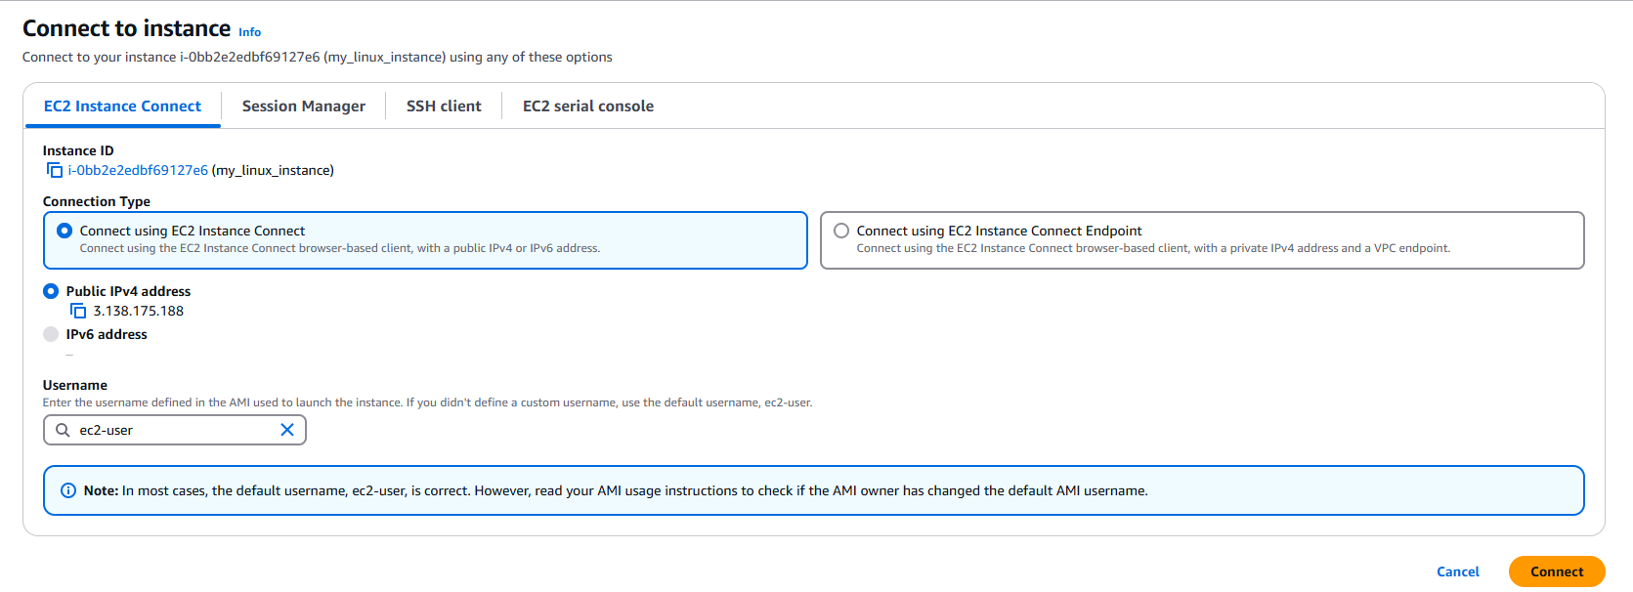

Update the system and install a web server (**Apache**):

* sudo yum update -y
* sudo yum install httpd -y
* sudo systemctl start httpd
* sudo systemctl enable httpd

Verify: Open < 3.138.175.188> in a browser. You should see the default Apache welcome page.

**2.2 Windows Instance**

* RDP into the Windows instance using local Remote Desktop client.

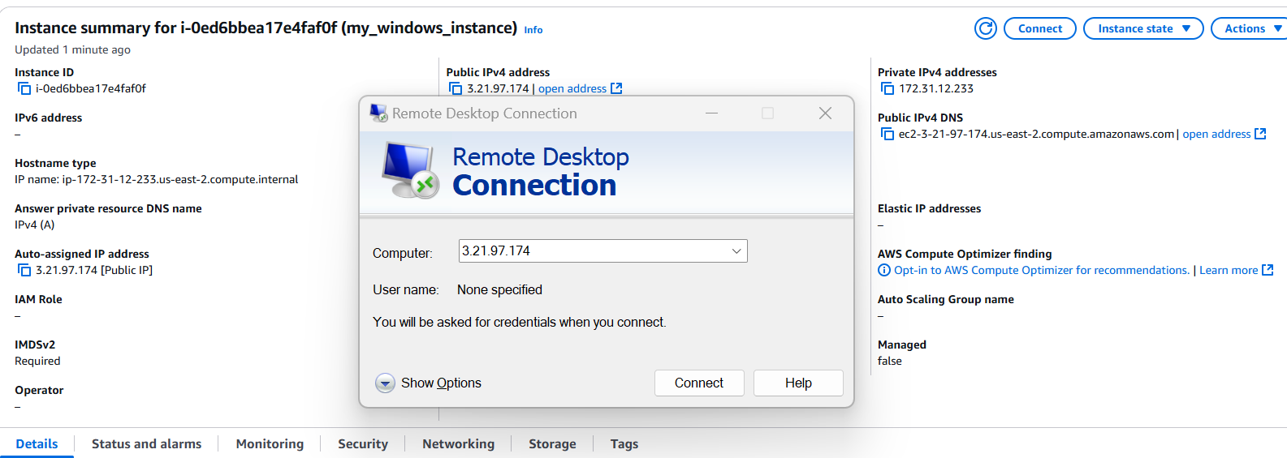

* Decrypt private key and get the password and username to login into the windows machine

* Install IIS in windows server

Verify: Open <http://3.21.97.174 > in a browser. You should see the IIS default welcome page.

**Step 3: Create and Attach EBS Volumes**

**3.1 Create an EBS Volume**:

* Go to **Volumes** under the EC2 dashboard.
* Click **Create Volume**.
* Set the size to **5 GB** and ensure the availability zone matches our EC2 instances.

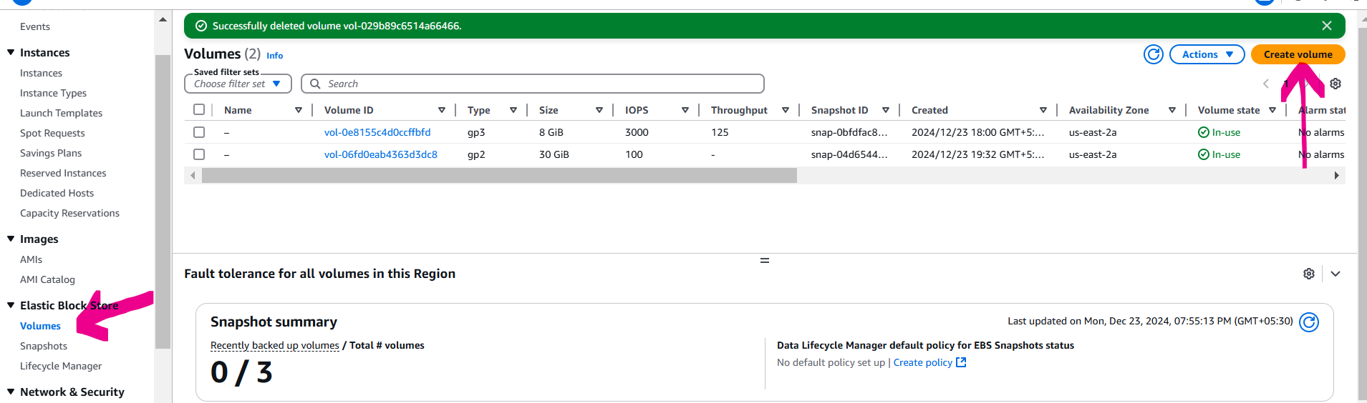

**3.2 Attach EBS Volume to Linux Instances**:

* Select the created volume, click **Actions > Attach Volume**.
* Attach it to the Linux instance. (**my_linux_instance**)

**3.3 Configure the Attached Volume:**

**Linux Instance**

* sudo file -s /dev/xvdb
* sudo mkfs -t ext4 /dev/xvdb
* sudo mkdir /data1
* sudo mount /dev/xvdb /data1
* echo '/dev/xvdf /data ext4 defaults,nofail 0 2' | sudo tee -a /etc/fstab

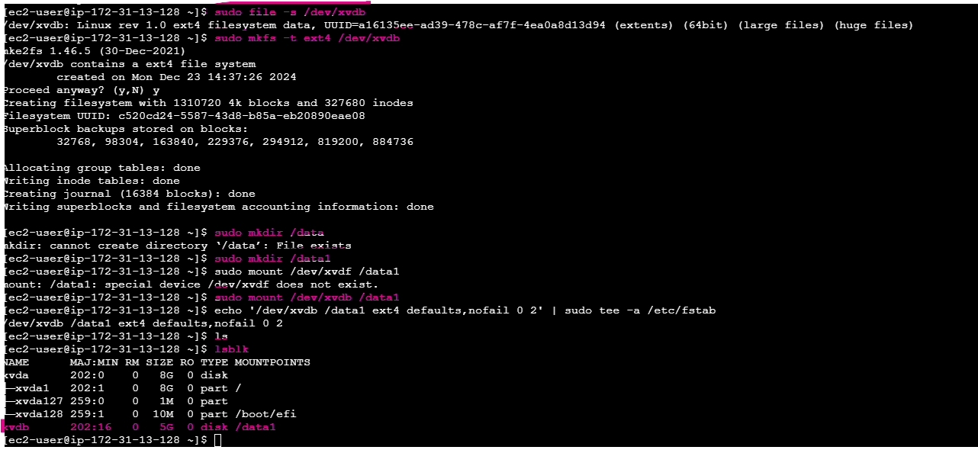

**3.4 Attach EBS Volume to Windows Instances**:

* Select the created volume, click **Actions > Attach Volume**.
* Attach it to the Linux instance. (**my_windows_instance**)

**3.3 Configure the Attached Volume:**

**Windows Instance**

* Open Disk Management
* Initialize Disk
* Format Disk
* Assign Drive letter

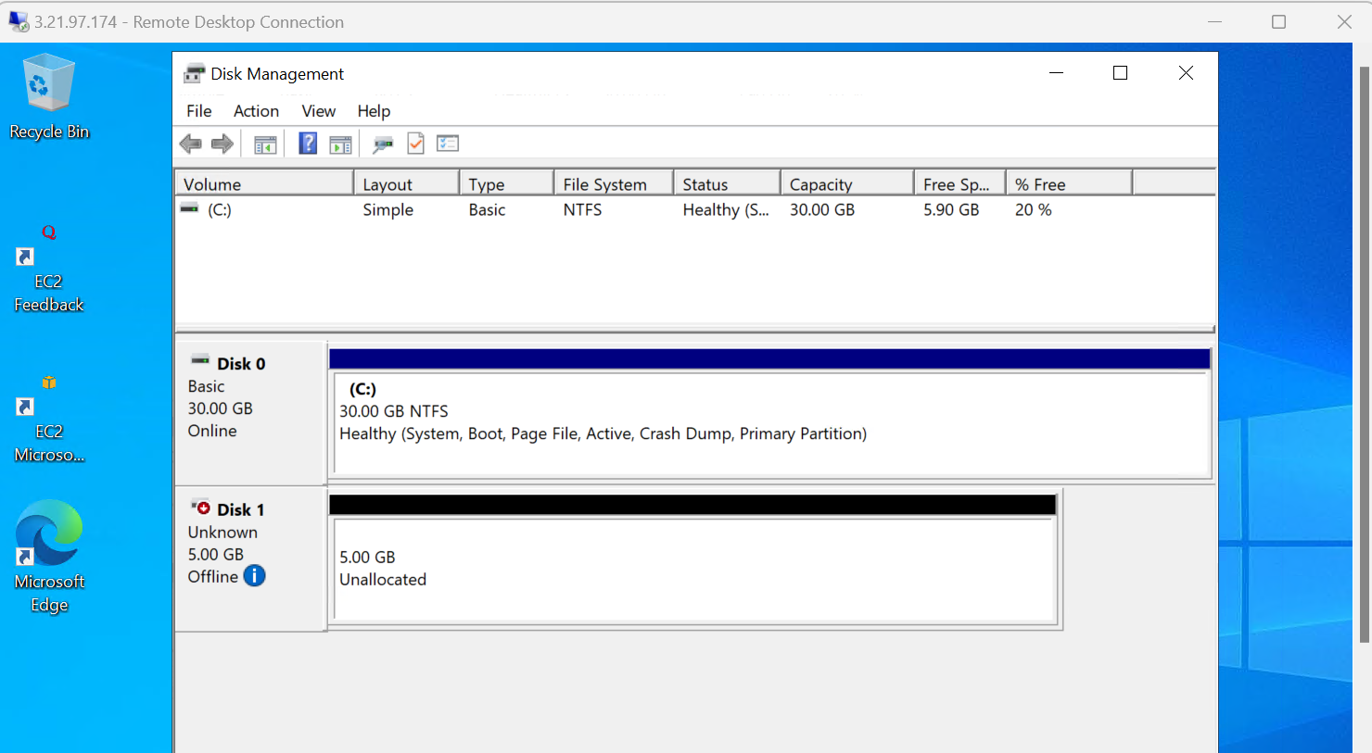

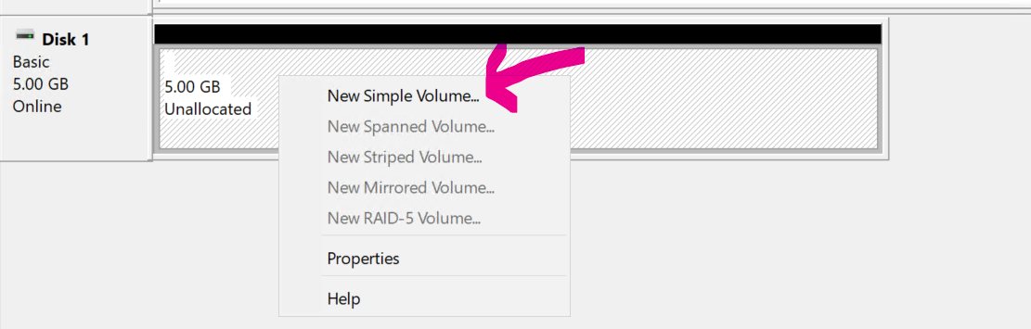

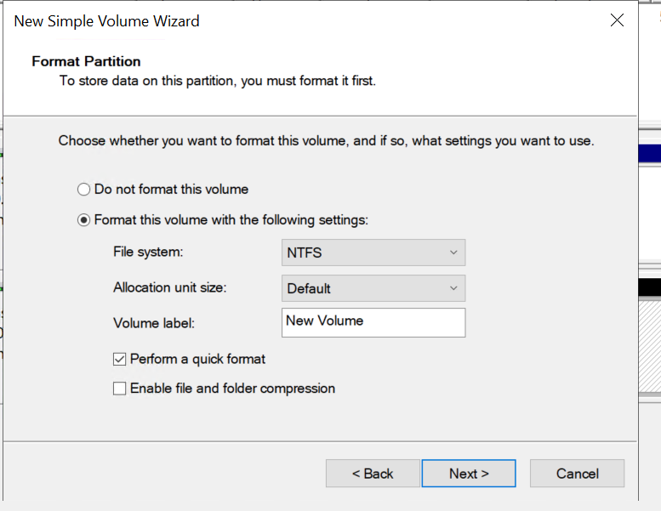

**Step 4: Take a Snapshot**

**Take Snapshot of EBS Volume:**

* Go to Volumes under the EC2 dashboard.
* Select the attached volume and click Actions > Create Snapshot.
* Provide a description and create a snapshot

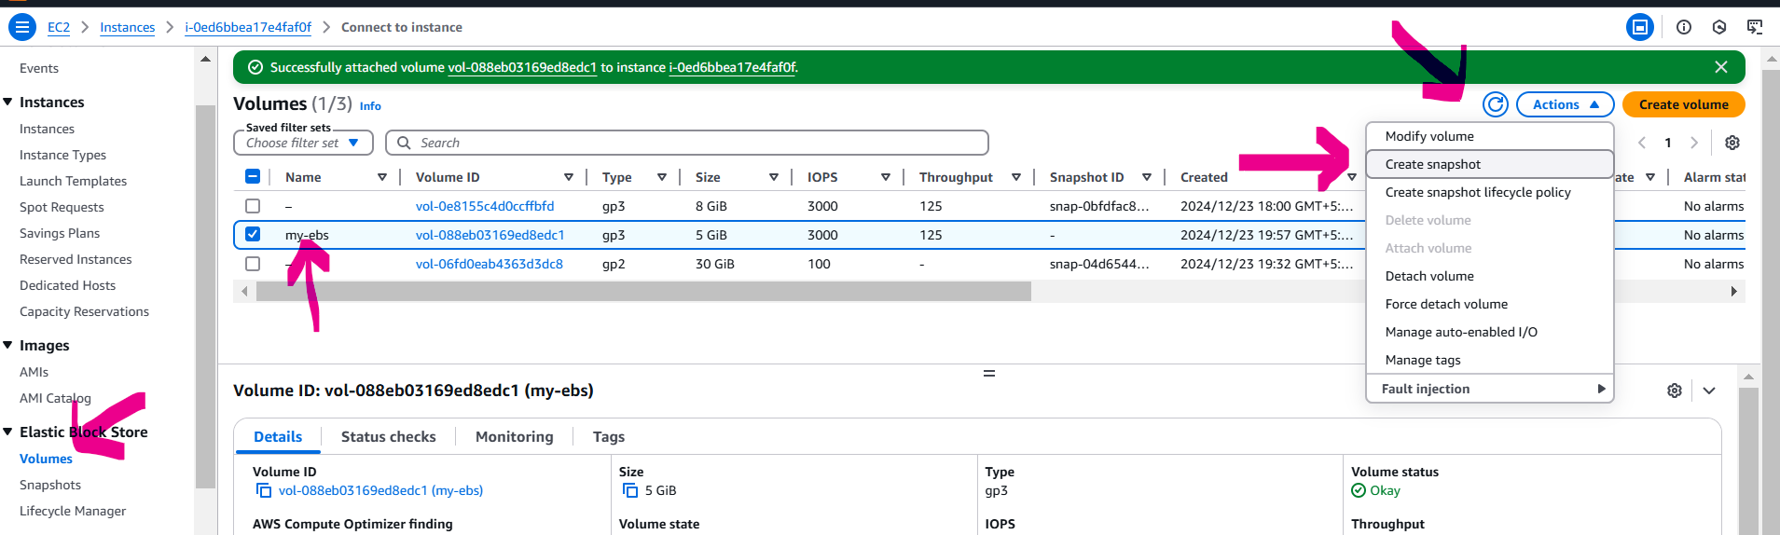

**Step 5: Create EBS Volume from Snapshot**

* 1. **Create Volume from Snapshot:**
* Go to Snapshots under the EC2 dashboard.
* Select the snapshot created, click Actions > Create Volume.
* Ensure the size and availability zone match the target EC2 instance.

**5.2 Attach the New Volume**:

* Attach the newly created volume to the desired instance (Linux or Windows).
* Configure the volume as described in Step 3.

**//////////////////////////////////////////////////////////////////////////////////////////////////////////**